Special Notes

Overview
The Special Notes feature in Petpooja allows restaurant staff to add, manage, and import custom instructions or notes linked to specific menu items. These notes help communicate specific requests to the kitchen or service staff efficiently. The feature can be accessed through the Menu & Discount section on the Petpooja billing dashboard.

Path : billing.petpooja.com > Menu > Menu & Discount >Special Notes
outletwise_link: https://menu.petpooja.com/items/special_note_list//

Step 1 : Billing.petpooja.com in Steps to reach Special Notes : Open your browser and go to billing.petpooja.com.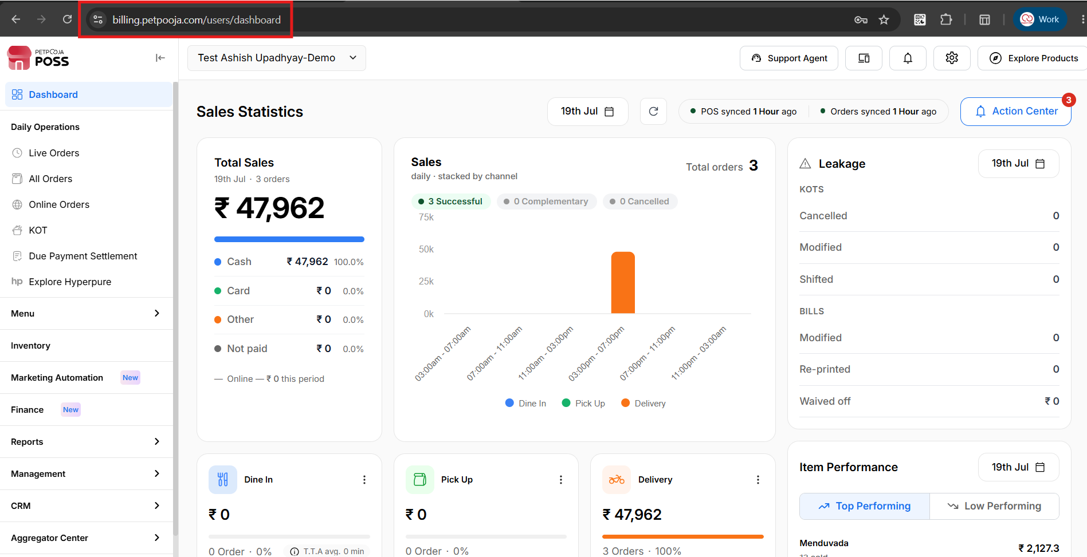
{Image Name: PetPooja Dashboard,
Description: The highlighted URL indicates that this is the billing.petpooja.com. Here is an image of Step 1 billing.petpooja.com in Steps to reach Special Notes.}
Step 2 : Menu in Steps to reach Special Notes : Click on the Menu section from the dashboard.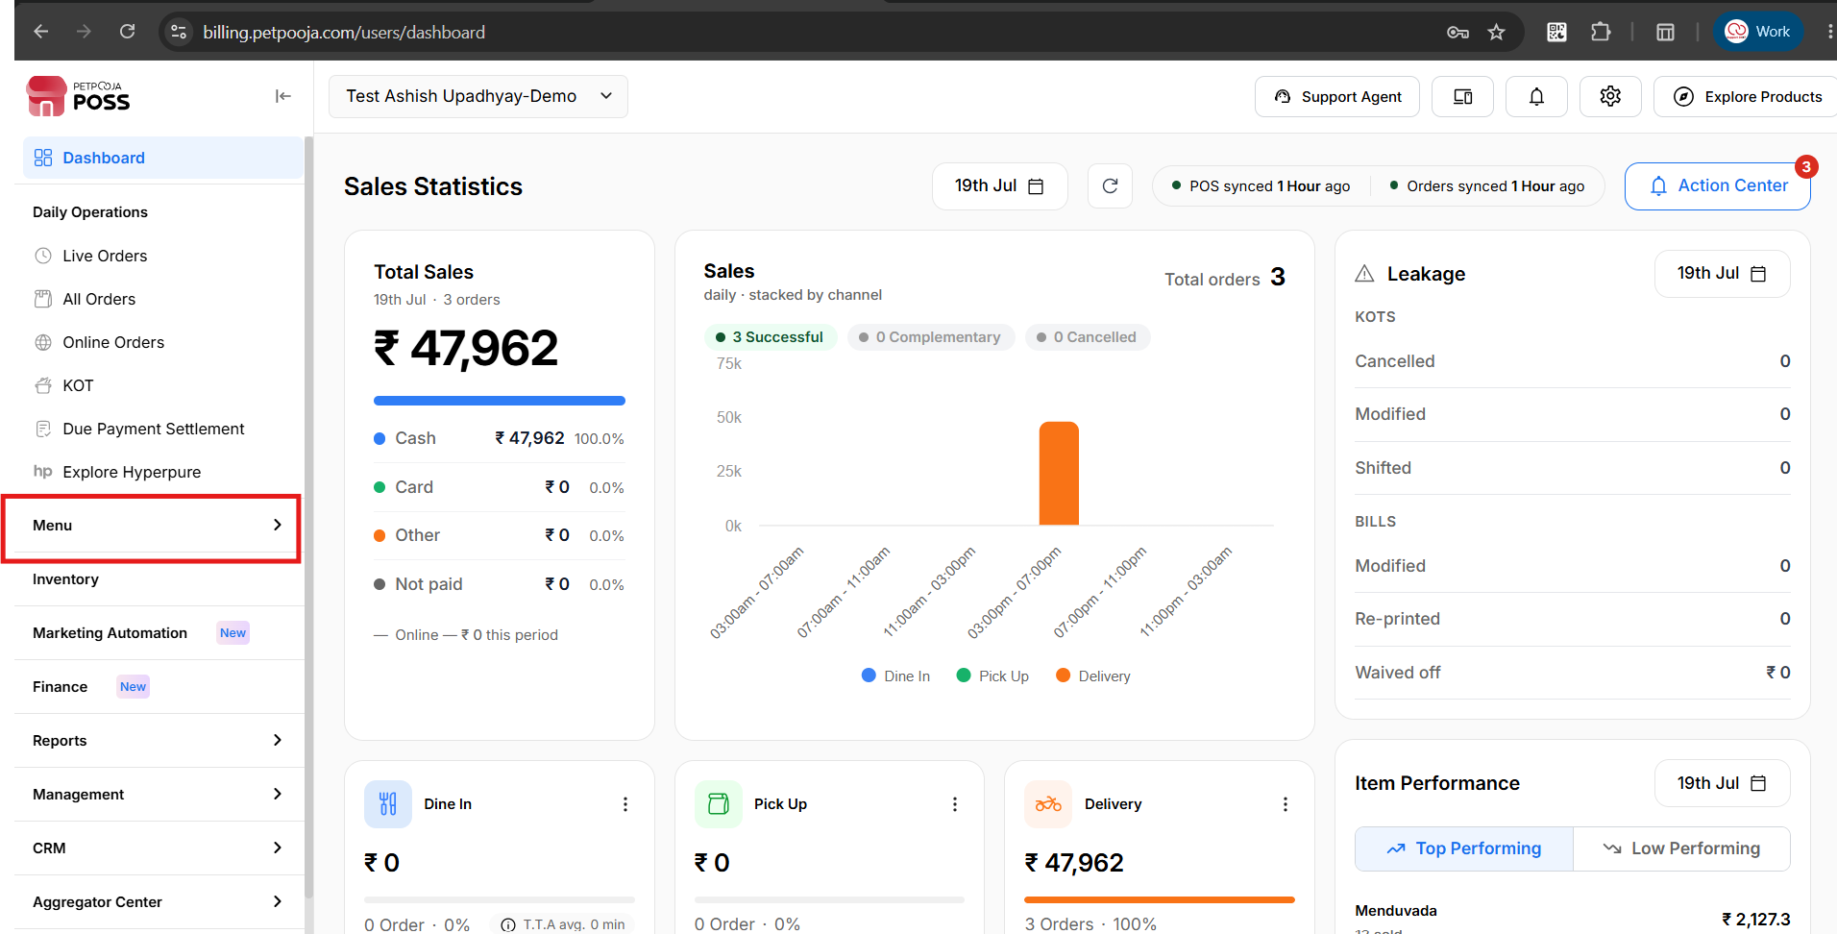
{Image Name: PetPooja Menu,
Description: The highlighted section indicates the "Menu" option on the left-side panel of the PetPooja dashboard. Here is an image of Step 2 Menu in Steps to reach Special Notes.}
Step 3 : Menu & Discount in Steps to reach Special Notes : Inside the Menu section, click on Menu & Discount.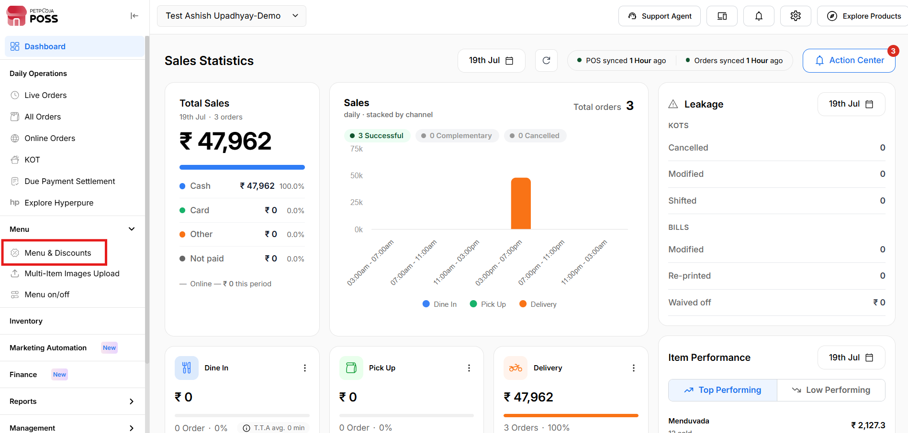
{Image Name: PetPooja Menu & Discount,
Description: The image shows the "Menu & Discount" section within the "Menu Management" page.Here is an image of Step 3 Menu & Discount in Steps to Reach Special Notes.}
Step 4 : Special Notes in Steps to reach Special Notes : Inside Menu & Discount, click on Special Notes.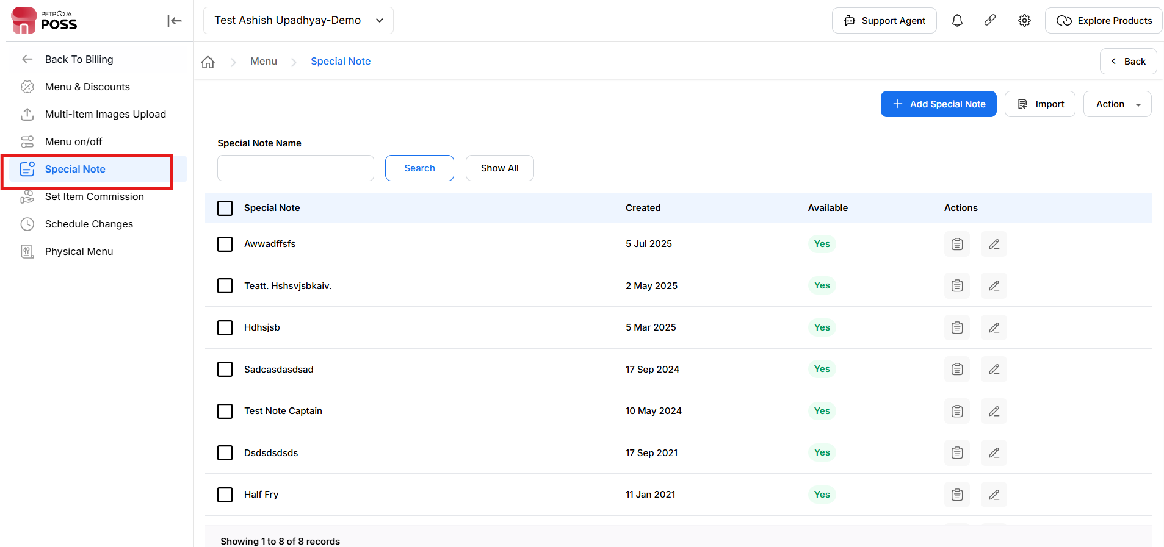
{Image Name: Special Note Section,
Description: The highlighted panel on the left shows the "Special Notes" section under Menu & Discount. Here is an image of Step 4 Special Notes in Steps to Reach Special Notes.}

Key features Of Special Notes :
outletwise_link: https://menu.petpooja.com/items/special_note_list//
- Special Note Name (Special Notes) : Allows users to search for a special note by name.
- Search (Special Notes) : Triggers the search based on the input.
- Show All (Special Notes) : Clears the search and displays all entries.

Action (Special Notes):
outletwise_link: https://menu.petpooja.com/items/special_note_list//
These actions help you manage special notes more easily. But to use any of them, you must first select at least one special note from the list.
- Mark as Available: Use this to make the selected special note active and usable in the system.
- Mark as Not Available: Use this if the selected note is currently not needed. It will be marked as inactive.
- Remove: This will permanently delete the selected special note from the system.
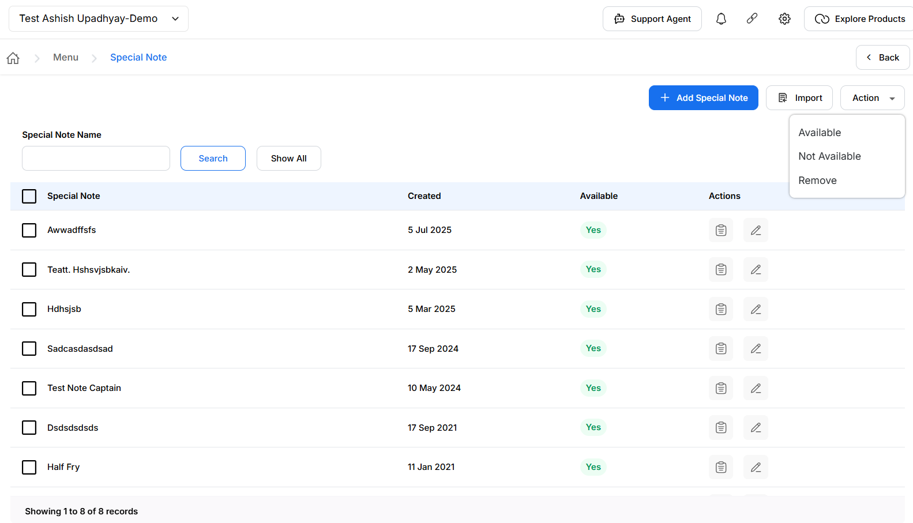
{Image Name: PetPooja Special Note Page,
Description: Here is an image showing the "Special Note" page in PetPooja. It displays options to add special notes, import data, and perform actions such as marking notes as Available, Not Available, or Remove.}

Add Special Notes (Special Note):
outletwise_link: https://menu.petpooja.com/items/special_note_list//
- For add special notes, you need to click on the "Add Special Note" button.
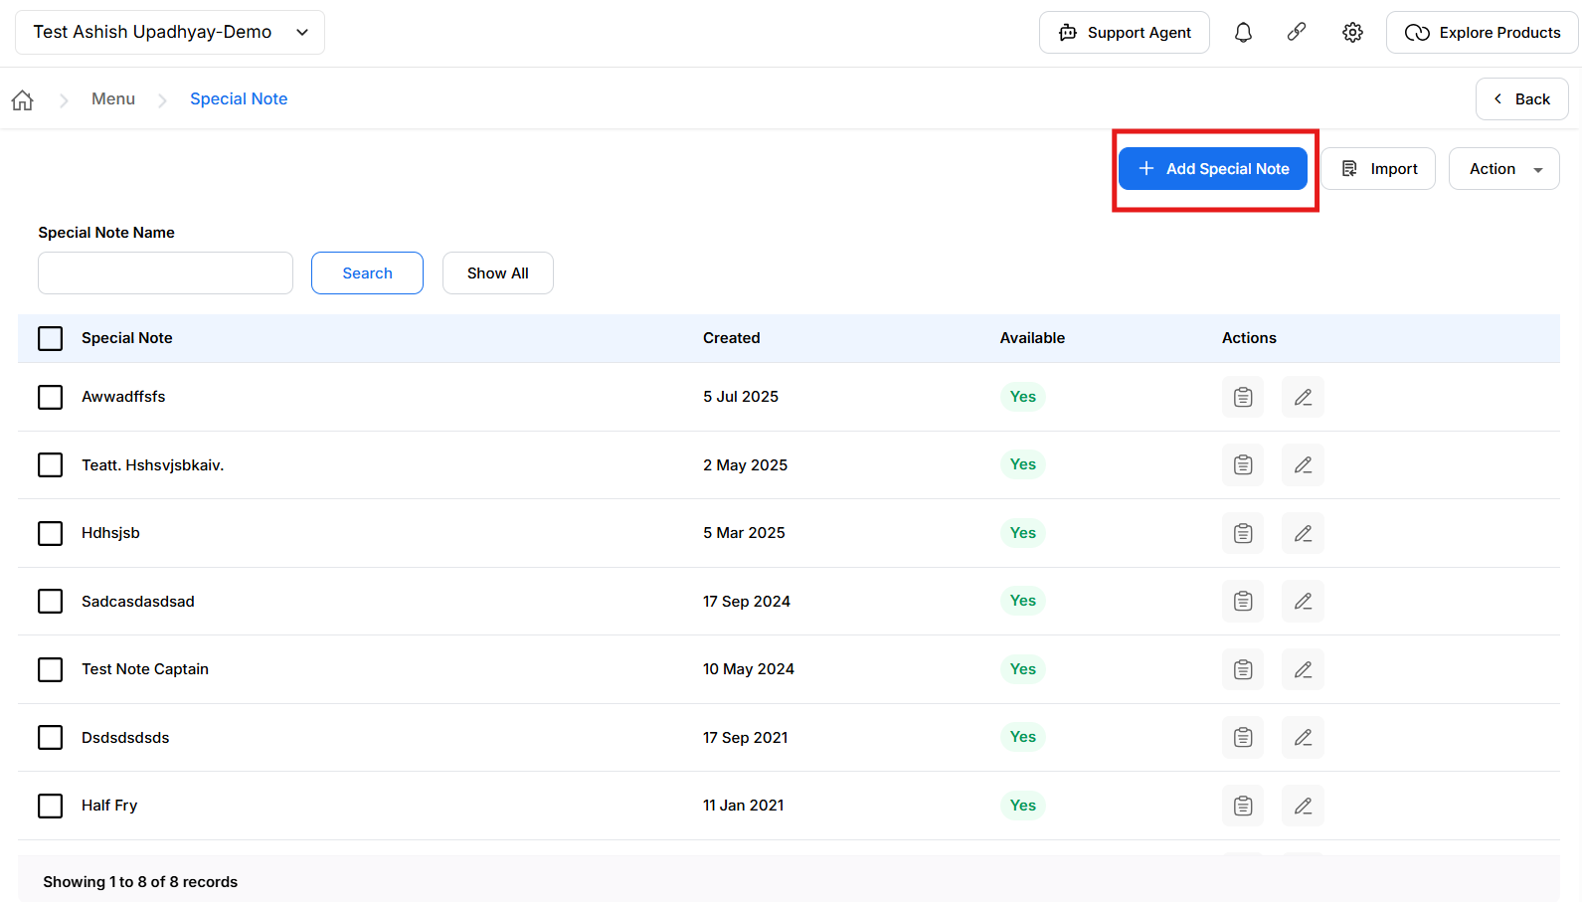
{Image Name: PetPooja Add Special Note,
Description: Here is an image that shows the "Add Special Note" button on the Special Note page in PetPooja.}
Fields (Add Special Notes):
outletwise_link: https://menu.petpooja.com/items/special_note_list//
- (Fields) Name (marked with a red asterisk * to indicate it is a required field): A text input where the user enters the name of the special note.
- (Fields) Available: A checkbox that can be toggled. It is currently checked, meaning the note will be marked as available when created.
- (Fields) Cancel: Closes the form without saving changes.
- (Fields) Save Changes (highlighted in red): Submits the form to save the new special note.
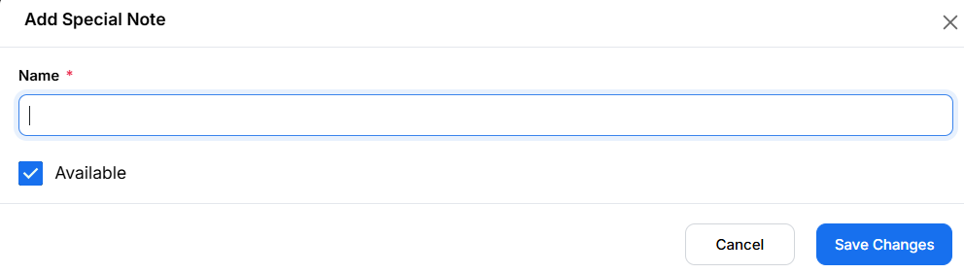
{Image Name: PetPooja Add Special Note Form,
Description: Here is an image that shows the "Add Special Note" form in PetPooja, where users can enter the note name and set its availability before saving changes.}

Import (Special Note):
outletwise_link: https://menu.petpooja.com/items/special_note_list//
- The Import button is used to upload special notes in bulk.

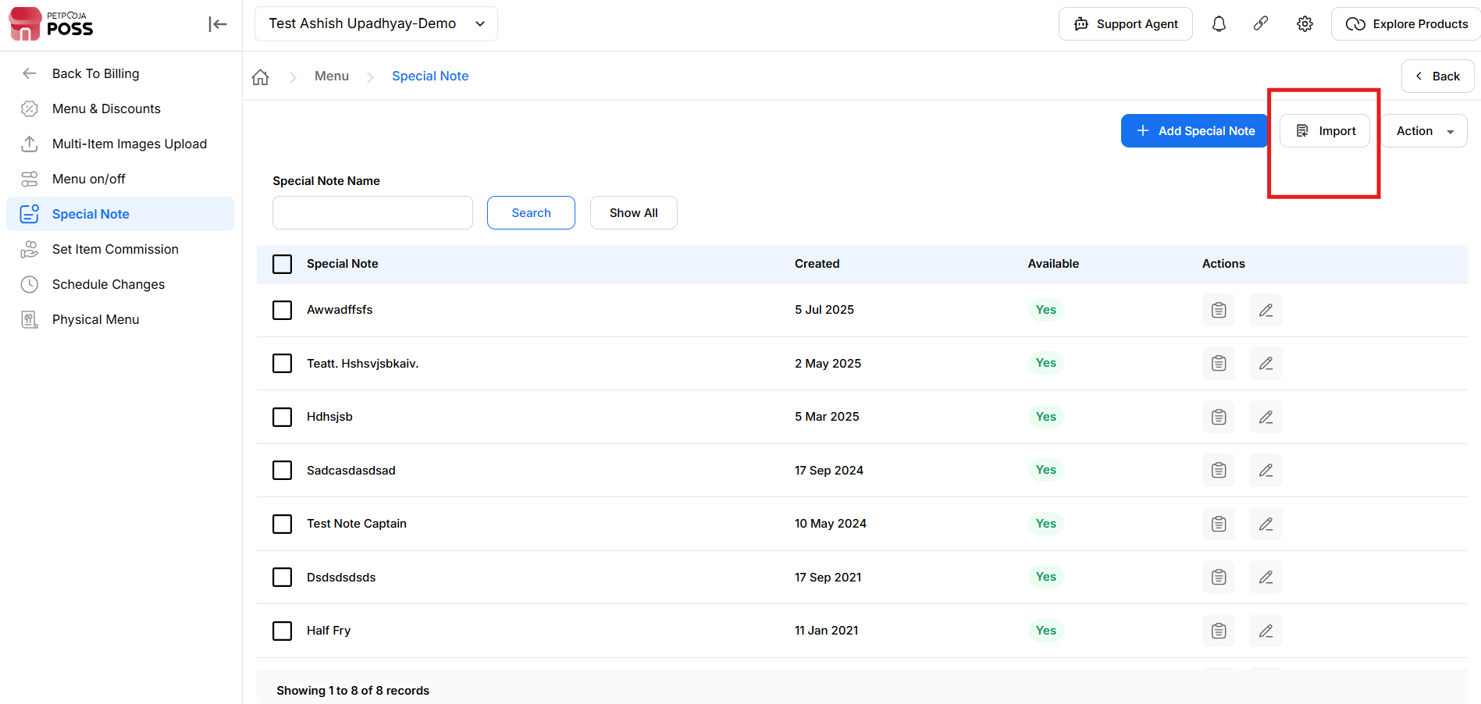
{Image Name: PetPooja Import Special Note,
Description: Here is an image that shows the "Import" button highlighted on the Special Note page in PetPooja, allowing users to bulk upload or import special notes into the system.}

- Id (Import) : Represents a unique identifier for each record (though not shown in this snippet),
- Note (Import) : "Leave 'Id' blank for adding new special notes"
- Special Note Name (Import) : Describes the note or label for an item (e.g., "Extra Spicy", "Med Spicy", "Extra Cheese"). This could be used in menus or item customization.
- Available (yes/no) (Import) : Indicates whether the note is currently available for selection or
Usage.
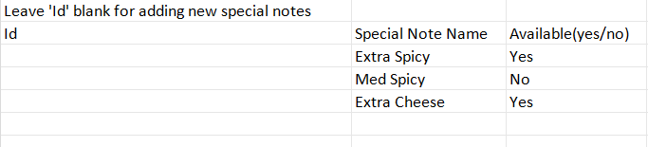
{Image Name: PetPooja Special Note Import Sheet,
Description: Here is an image that shows the sample import sheet for Special Notes in PetPooja, where users can add multiple notes by specifying the name and availability status, leaving the 'Id' column blank for new entries.}

- (Import) Choose File : Lets the user browse their computer and select a file (CSV) that contains the special notes they want to import.
- (Import) Download Special Note(S) : Downloads a sample/template file. This likely helps users format their data correctly before uploading.
- (Import) Cancel : Closes the import dialog without performing any action.
- (Import) Upload : Initiates the file upload and import process. The system will then read the file, validate the data, and add/update records accordingly.

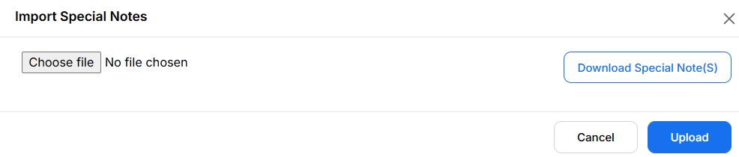
{Image Name: PetPooja Import Special Notes,
Description: Here is an image showing the “Import Special Notes” dialog box in PetPooja, where users can upload a file containing special notes.}

Actions (Special Notes) :
outletwise_link: https://menu.petpooja.com/items/special_note_list//

View Icon (Actions) :
outletwise_link: https://menu.petpooja.com/items/special_note_list//
- View or Details (View Icon) :This icon usually indicates viewing detailed information or a read-only version of the record (e.g., viewing the full "Special Note" details without editing).

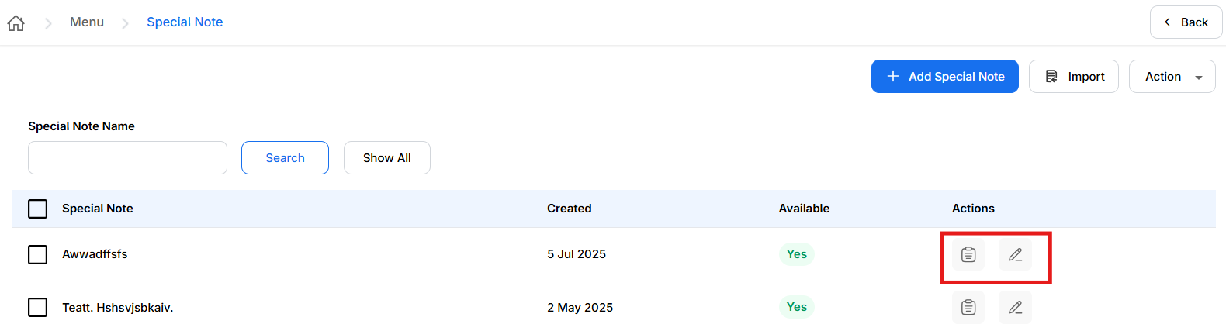
{Image Name: PetPooja Edit or Delete Special Notes,
Description: Here is an image showing the Special Notes listing interface in PetPooja. The image highlights the "Actions" column, where users can edit or delete existing special notes using the pencil (edit) and trash bin (delete) icons respectively.}

Pencil Icon (Actions):
outletwise_link: https://menu.petpooja.com/items/special_note_list//
- Edit (Pencil Icon) : Clicking this button would typically allow the user to edit an existing record, such as modifying a special note's name or availability status.
Name * (Pencil Icon):
outletwise_link: https://menu.petpooja.com/items/special_note_list//
- A text input field where the user can update the name of the special note.
- In the screenshot, the current value is "Extra Cheese".
Available (Pencil Icon) :
outletwise_link: https://menu.petpooja.com/items/special_note_list//
- A toggle to indicate whether the special note is currently available.
- The checkbox is checked, meaning "Available" is set to Yes.
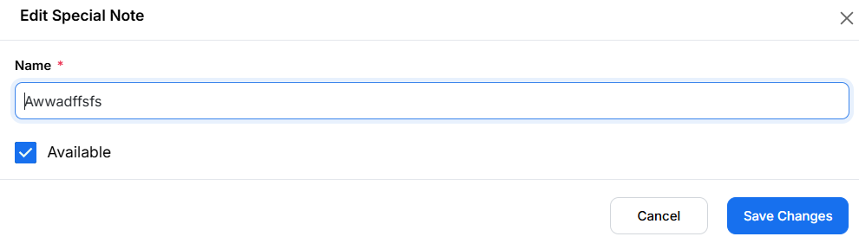
{Image Name: PetPooja Edit Special Note,
Description: Here is an image showing the "Edit Special Note" form in PetPooja. The interface allows users to update the name of the special note and its availability status. Users can save changes or cancel the action using the respective buttons at the bottom of the form.}
Note (Special Notes): If any changes are made in the Schedule Changes from the dashboard, manual sync is mandatory in POS/Billing Application.

